CS 251 Statistical Computing

**HOP01A –Visual Studio Code (VS Code)**

8/7/2019 Developed by Clark Jason Ngo

11/16/2019 Updated by Apiwat Chuaphan

10/16/2020 Reviewed by Shanshan Yu

Center for Information Assurance (CIAE) @City University of Seattle (CityU)



**Before You Start**

* If you already finished this module through other CityU School of Technology and Computing (STC) courses, feel free to skim this activity. But verify VSCode installation in your computer.
* Version numbers may not match with the most current version at the time of writing. If given the option to choose between stable release (long-term support) or most recent, please choose the stable release rather than beta-testing version.
* This tutorial targets Windows users and MacOS users.
* There might be subtle discrepancies along the steps. Please use your best judgement while going through this cookbook style tutorial to complete each step.
* For your working directory, use your course number. This tutorial may use a different course number as an example.

**Learning Outcomes**

* Installing VS Code
* Making your development directory

**Installing Visual Studio Code**

**Windows**

Installation

1. Visit <https://code.visualstudio.com/>

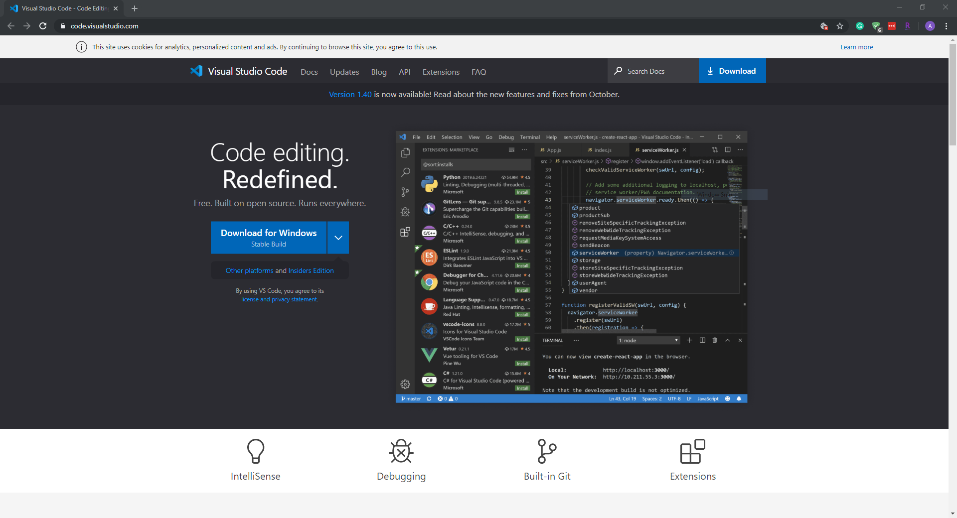

1. Select a correct version for your operating system and download it.  
   For example, you can download “VSCodeUserSetup-x64-1.40” for your Windows 10. (As of October 2019)

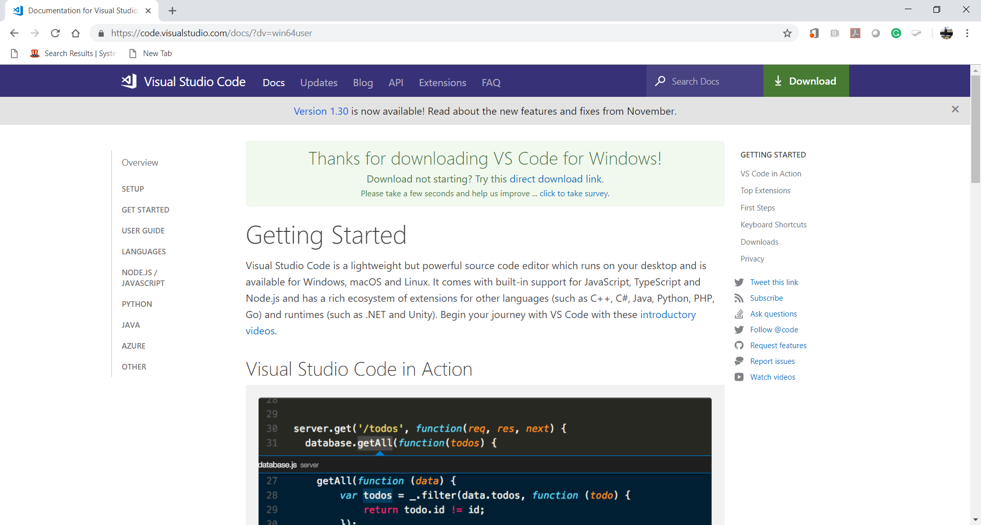

1. Install VSCode.

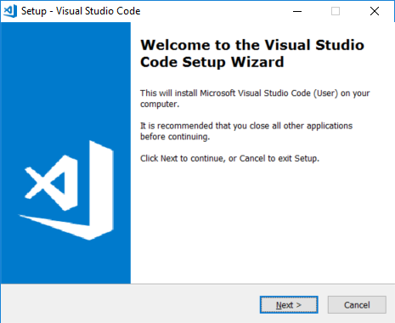

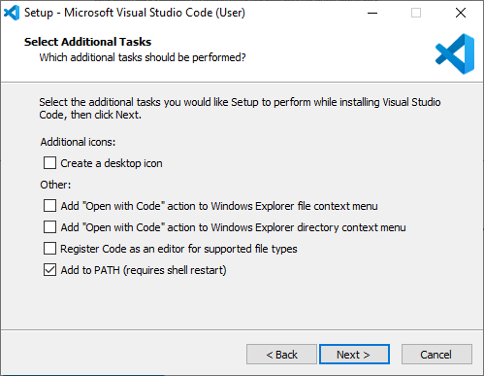

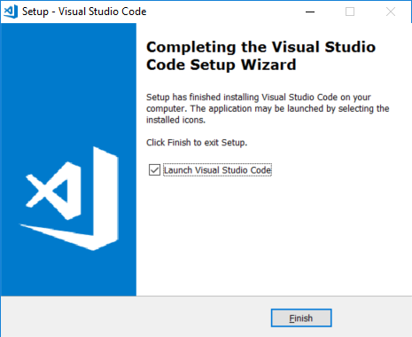  
  
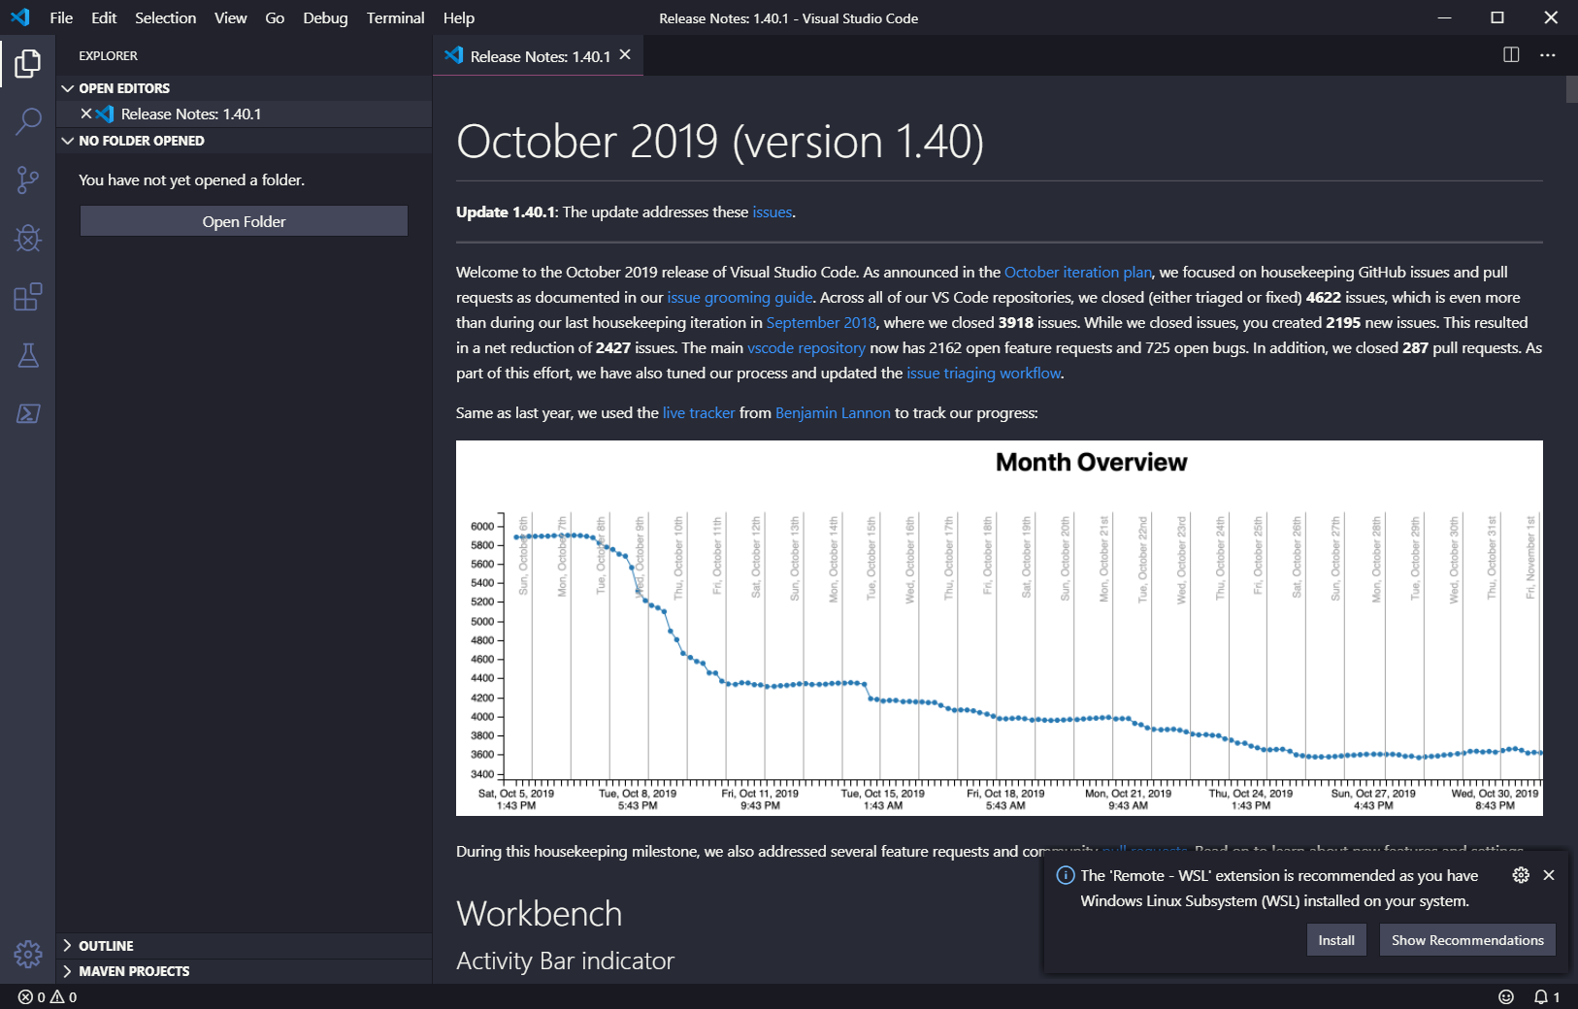

1. After installing the VSCode, close the opened VSCode.  
   Go to “File” menu end select ‘Exit” menu item.

**macOS**

Installation

1. Visit <https://code.visualstudio.com/>

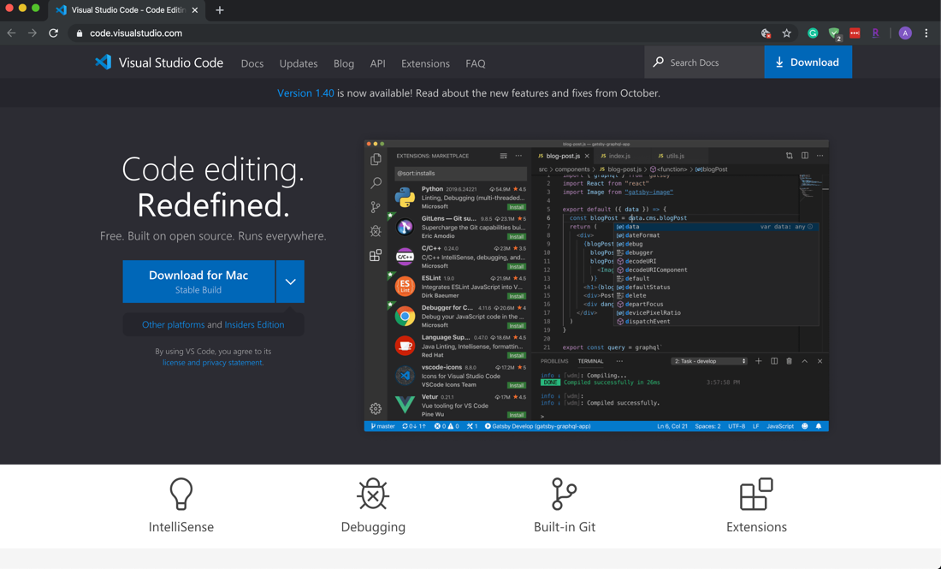

1. Click Download for macOS
2. Double-click on the downloaded archive to expand the contents.
3. Drag Visual Studio Code.app to the Applications folder, making it available in the Launchpad.
4. Add VS Code to your Dock by right-clicking on the icon to bring up the context menu and choosing Options, Keep in Dock.

Launching from the command line

(You can also run VS Code from the terminal by typing 'code' after adding it to the path)

* Launch VS Code.
* Open the Command Palette (F1) and type 'shell command' to find the Shell Command: Install 'code' command in PATH command.

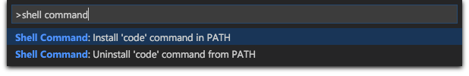

* Restart the terminal for the new $PATH value to take effect. You'll be able to type 'code .' in any folder to start editing files in that folder.

**Making your development directory**

1. Open the VSCode again.
2. Go to “View” menu and select “Terminal” menu item for your Command Line Interface (CLI).

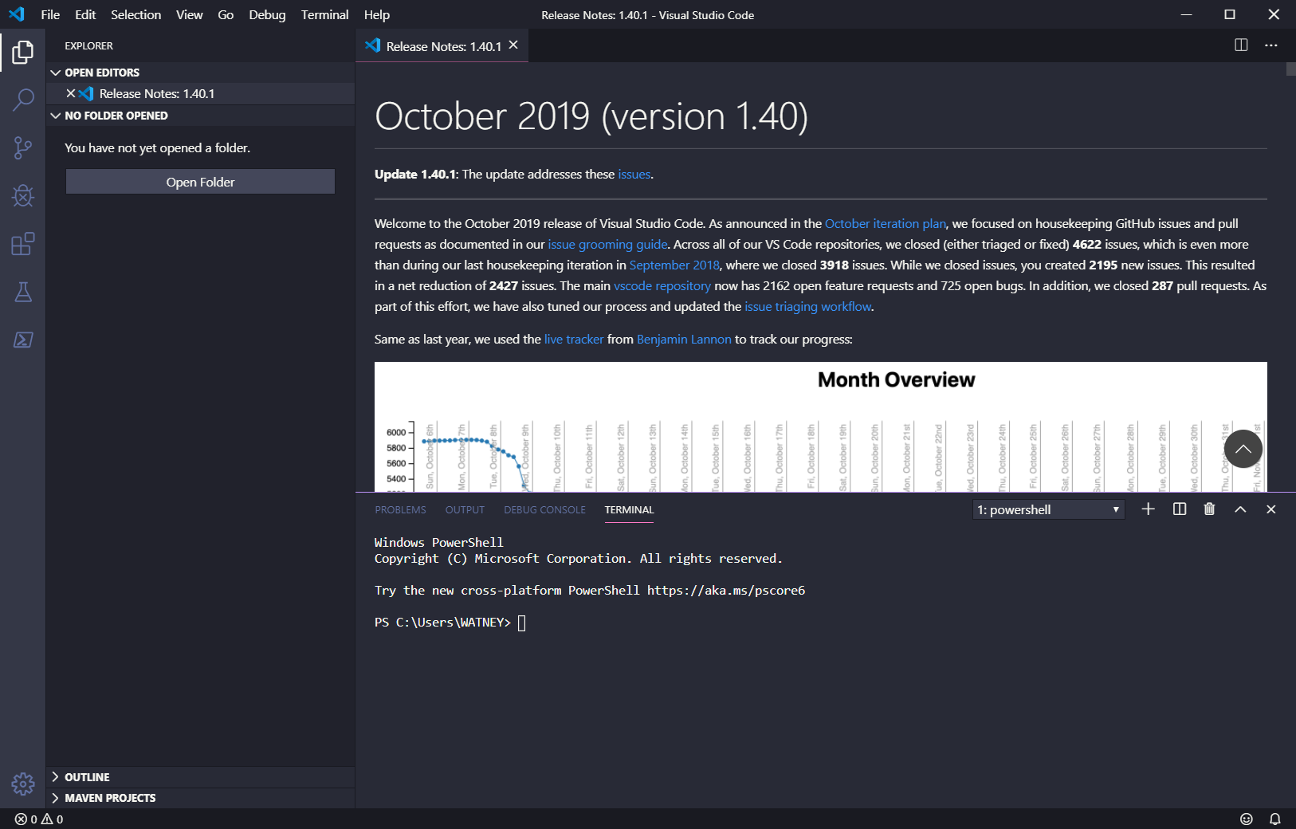

1. Go to the location you like to save the work (e.g., home directory by typing **cd** in the terminal).

We will clone the directory from GitHub in the next session.

References to create a directory:

For Windows:   
<https://www.digitalcitizen.life/command-prompt-how-use-basic-commands>  
<https://www.thomas-krenn.com/en/wiki/Cmd_commands_under_Windows>

For Mac:

<https://www.cs.virginia.edu/diochnos/tips/terminal/basics.html>

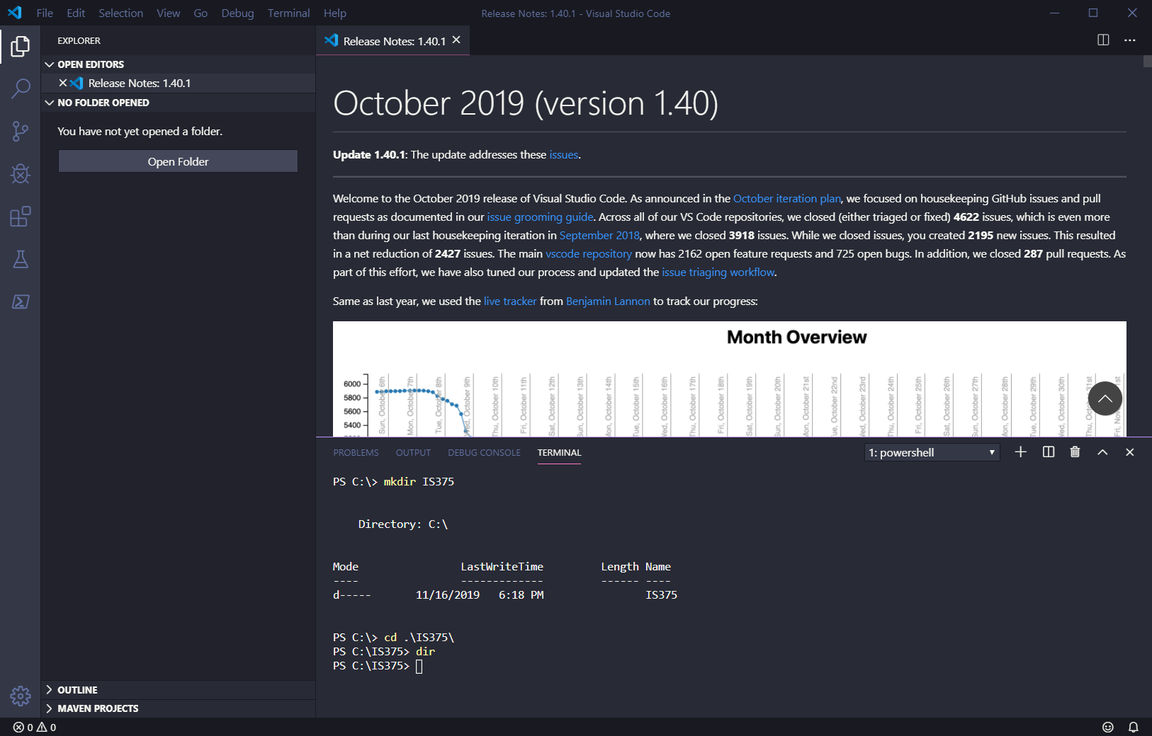

This example uses Windows commands, for macOS users, use commands mentioned above

1. Clear your CLI.  
   >>> cls (macOS, use clear)
2. Close the VSCode.

### ENJOY CODING 😄 ###